HTML
- HTML stands for Hyper Text Markup Language
- HTML describes the structure of a Web page
- HTML consists of a series of elements
- HTML elements tell the browser how to display the content
- HTML elements are represented by tags
- HTML tags label pieces of content such as ”heading”, ”paragraph”, ”table”, and so on
- Browsers do not display the HTML tags, but use them to render the content of the page

A Simple HTML Document
<!DOCTYPE html>
<html>
<head>
<title>Page Title</title>
</head>
<body>

<h1>My First Heading</h1>
<p>My first paragraph.</p>

</body>
</html>

Explanation

- The <!DOCTYPE html> declaration defines this document to be HTML5
<html>
<head>

- The
- The
element is the root element of an HTML page
element contains meta information about the document

- The <title> element specifies a title for the document
- The <body> element contains the visible page content
- The <h1> element defines a large heading
- The <p> element defines a paragraph
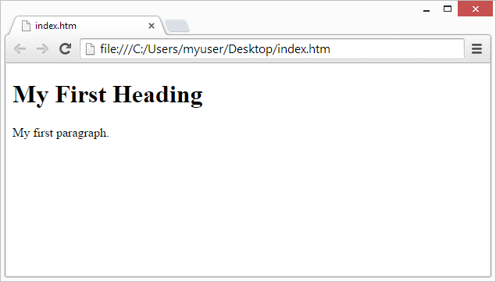

Fig 1: Output of the Simple HTML Document

HTML Basic tags
Tag / Syntax | Description
<html></html> | Start and end document
<h1></h1> | Header size 1–6 (large to small)
<p></p> | Paragraph
<br> | Break the line
&nbsp; | Non‑breaking space
<strike></strike> | Strike through
<b></b> | Bold the text
<i></i> | Italics (font)
<u></u> | Underline the text
<a href="url">text</a> | Basic link
<img src="url" alt="text"> | Basic image
src="url" | Source (URL or filename)
alt="text" | Alt (hover) text
<table></table> | Basic table
<li></li> | List item
width="Number" | Line/image width by number
height="Number" | Line/image height by number
HTML Forms:
An HTML form is used to collect user input. The user input can then be sent to a server for processing.
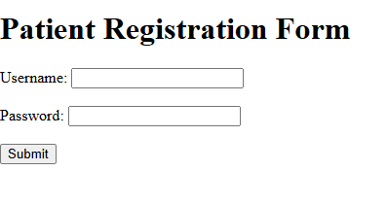
Fig 2: Login Form
<html>
<head>
<title>Patient Registration Form</title>
</head>

<body>

<h1>Patient Registration Form</h1>

<form>

Username:
<input type="text" name="username">
<br><br>

Password:
<input type="password" name="password">
<br><br>

<input type="submit" value="Submit">

</form>

</body>
</html>

What this code does
- <h1> → Displays the Patient Registration Form title
- <form> → Creates a form section
- <input type="text"> → Username input box
- <input type="password"> → Password input box
- <input type="submit"> → Submit button
- <br> → Adds spacing between lines
The HTML <form> element defines a form that is used to collect user input.
The <input> element is the most important form element.
The <input> element is displayed in several ways, depending on the type attribute.
• <input type="button">
• <input type="checkbox">
• <input type="date">
• <input type="email">
• <input type="file">
• <input type="hidden">
• <input type="image">
• <input type="password">
• <input type="radio">
• <input type="reset">
• <input type="range">
• <input type="submit">

Practice 1

Imagine you’re a computer science student preparing for an internship. Your goal is to build a personal webpage to introduce yourself to potential employers. The homepage should clearly show your name, a short description, your education table, and a form for visitors to contact you. Use semantic HTML5 tags to structure your content clearly (header, main, footer).

Steps: Design a personal portfolio page using HTML semantic elements. Include:
- A header with your name and navigation bar (, ).
- A short biography section ().
- A table showing your educational qualifications.
- A contact form.
- Metadata in the section (title, author, description, keywords).

Practice 2

You are assigned to build a university’s online admission form for new students. The form should collect personal details, academic background, preferred department, and necessary documents. Use clear field labels, grouped sections (Personal Info, Academic Info), and a Submit/Reset button.

Steps:

  - Create a well-structured admission form using the <form> element as the container.
  - Organize form sections logically by grouping related information inside <fieldset> tags.
  - Provide a clear title for each section using the <legend> element within every <fieldset>.
  - Implement a variety of input types to collect different kinds of data, including:
    - text for names and general information.
    - email for email addresses.
    - radio buttons for mutually exclusive options (e.g., Gender).
    - checkbox for multiple selections (e.g., Interests).
    - dropdown (<select>) for a list of choices (e.g., Course Selection).
    - date for selecting a date.
    - file for uploading documents like resumes or transcripts.
  - Apply client-side validation using HTML5 attributes:
    - Use the required attribute to mark essential fields.
    - Use the maxlength attribute to restrict the number of characters in a text field.

Practice 3

You have been hired by a new digital media company, DailyFlash, to design their news website’s homepage and its category pages. The company wants a professional, multi-page layout that is easy to navigate and visually organized. The homepage (index.html) should showcase the three latest news stories in different categories — for example, “World Leaders Meet for Climate Summit,” “National Team Wins Championship,” and “New Smartphone Sets Record Sales.” A sidebar should display Top Headlines, giving visitors a quick glance at trending stories, and an advertisement space for sponsors. The footer must look uniform across all pages, showing copyright, social links, and company credits. Your task is to ensure the entire website looks consistent, properly structured with semantic HTML tags, and all links work correctly across the 3 pages.

General Requirements:

  - Create a multi-page website with at least 3 HTML pages:
    - index.html – Homepage (main news page)
    - world.html – World News section
    - sports.html – Sports section
  - Each page must share a consistent layout and navigation bar.

Steps:

- Header Section (<header>)

  - Include the site name: DailyFlash inside a heading tag (e.g., <h1>).
  - Add a slogan or tagline under the site name (e.g., “Your Source for Instant News”).
  - Optionally, include a small logo image on the left side of the title.

- Navigation Bar (<nav>): Create a navigation menu with the following links:

  - Home
  - World
  - Sports
  - Tech
  - Lifestyle
  - Contact

- Use an unordered list (<ul>) for navigation links.
- Highlight the current page (e.g., make “Home” bold or visually distinct).
- All navigation links should correctly point to their respective pages (use relative links).

- Main Content Area (<main>)

  - Include three recent news articles using <article> elements.
  - Each <article> must contain:

    - A headline inside <h2>.
    - A publication date (<small> or <time> tag).
    - A thumbnail image representing the article.
    - A summary paragraph (3–4 sentences).
    - A “Read More” link pointing to a detailed page (optional).

  - Use a horizontal rule (<hr>) to separate articles.

- Sidebar Section (<aside>)

  - Title the sidebar as Top Headlines.
  - Use a list (<ul> or <ol>) to show 5 short headline links.
  - Add a small “Trending” or “Editor’s Pick” area below it with 1–2 highlighted headlines.
  - Include one small advertisement box or promotional message using a <div>.

- Footer Section (<footer>)

  - Copyright notice (© 2025 DailyFlash)
  - Social media links (use dummy URLs or #):
    - Facebook
    - X (Twitter)
    - Instagram
    - LinkedIn

  - A small note: “All Rights Reserved.”

- Page Navigation

  - All links in the navigation bar must allow the user to move between pages without dead links.
  - Example: clicking “World” opens world.html, “Sports” opens sports.html.

